EXP 06

**Create a simple cloud software application for Payroll Processing System using any Cloud Service Provider to demonstrate SaaS include the necessary fields such as Name of the employee, experience in present org , over all experience, basic pay, HRA, DA, TA, net pay, gross pay etc**

STEP 1: Sign in to the zoho.com and click the creator option

STEP 2: After enter into the creator click the create solution

R.Akash 192121091

STEP 3: To create the application by select the application

STEP 4: After selection the application to create the new component form

R.Akash 192121091

STEP 5: Click and open the scratch from the form

STEP 6: Enter the name of the form to crate the form

R.Akash 192121091

STEP 7: choose any form of template to create the page form

STEP 8: To create the form pages of the application by basic fields

R.Akash 192121091

STEP 9: The first form is to create the new employee information form

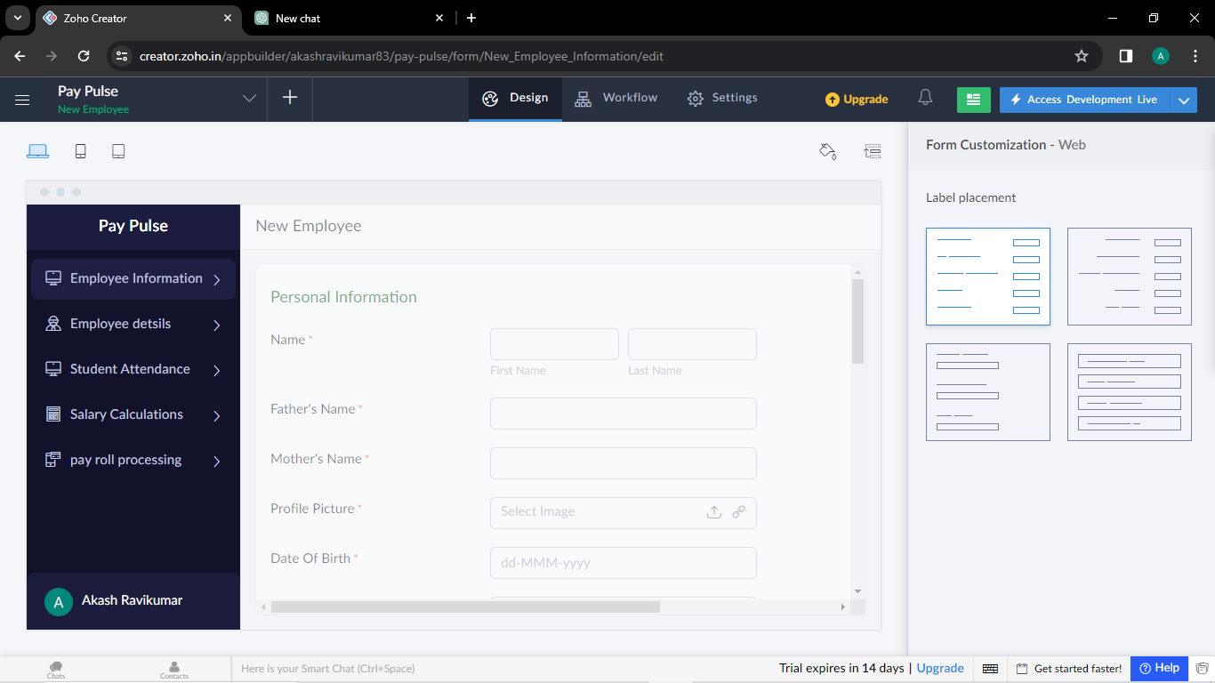

STEP 10: The second form is create the employee details

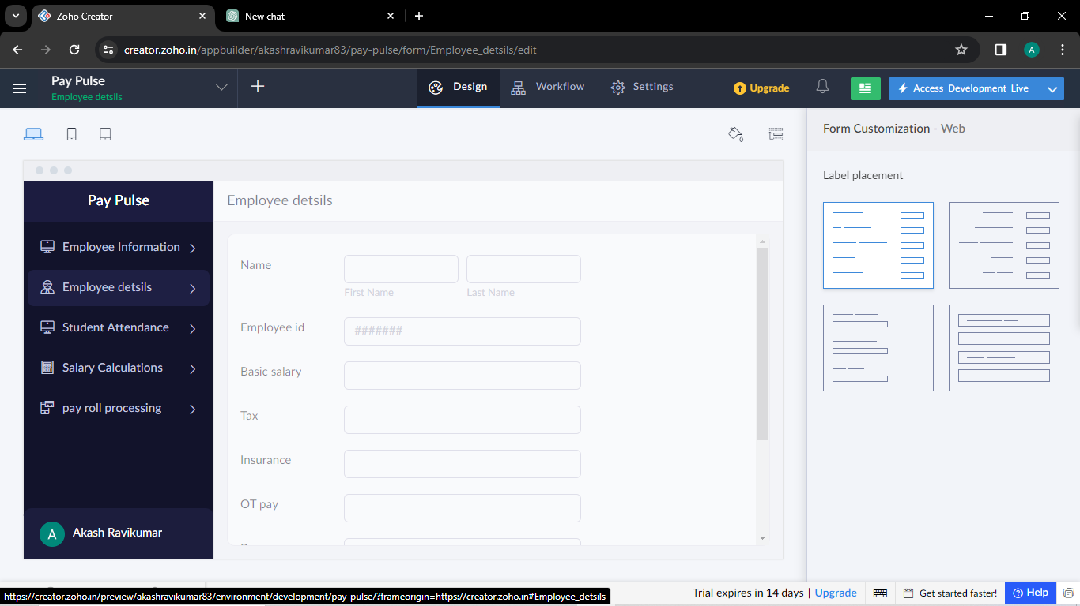

R.Akash 192121091

STEP 11:The third form is to create the employee attendance form

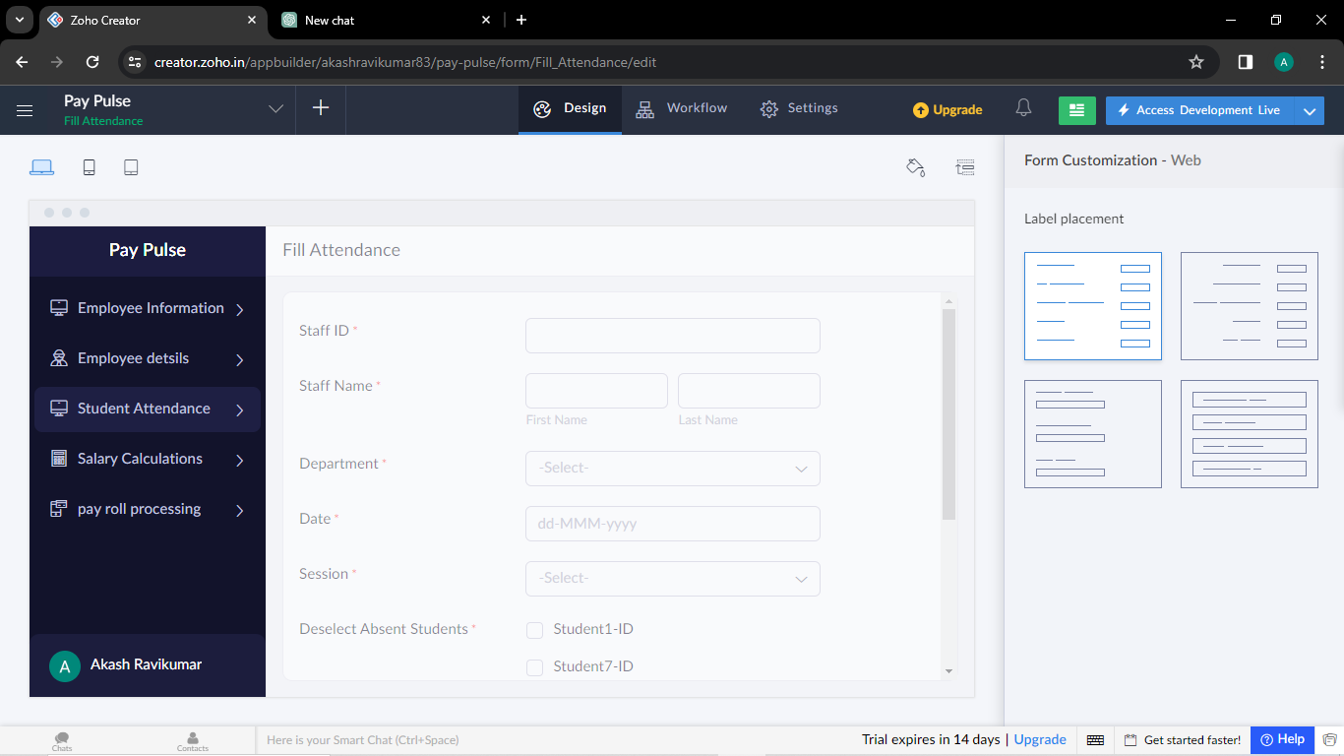

STEP 12: the fourth form is to create the Salary calculation form

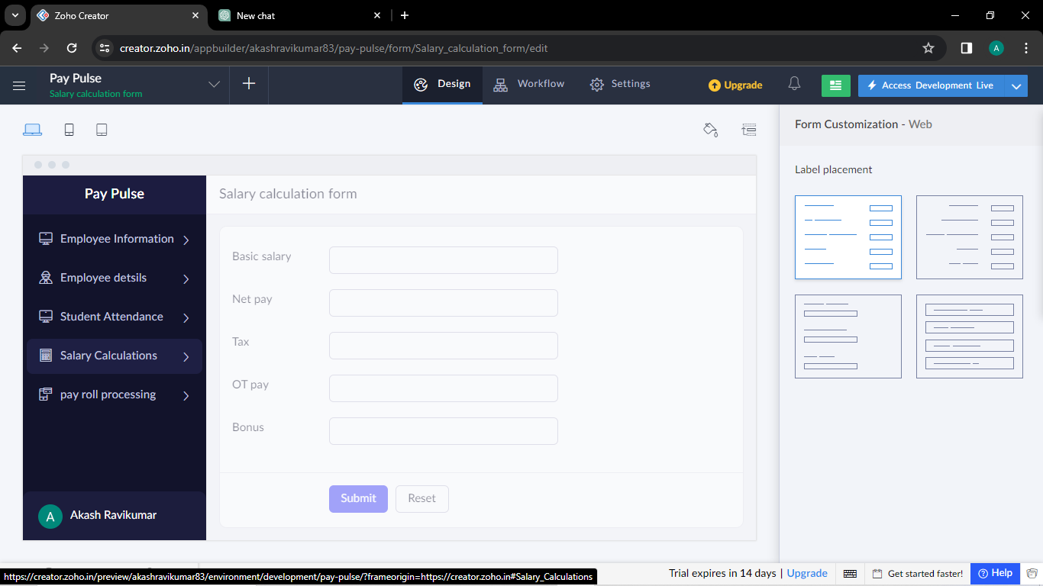

R.Akash 192121091

STEP 13: the fifth form is to create the payroll processing form

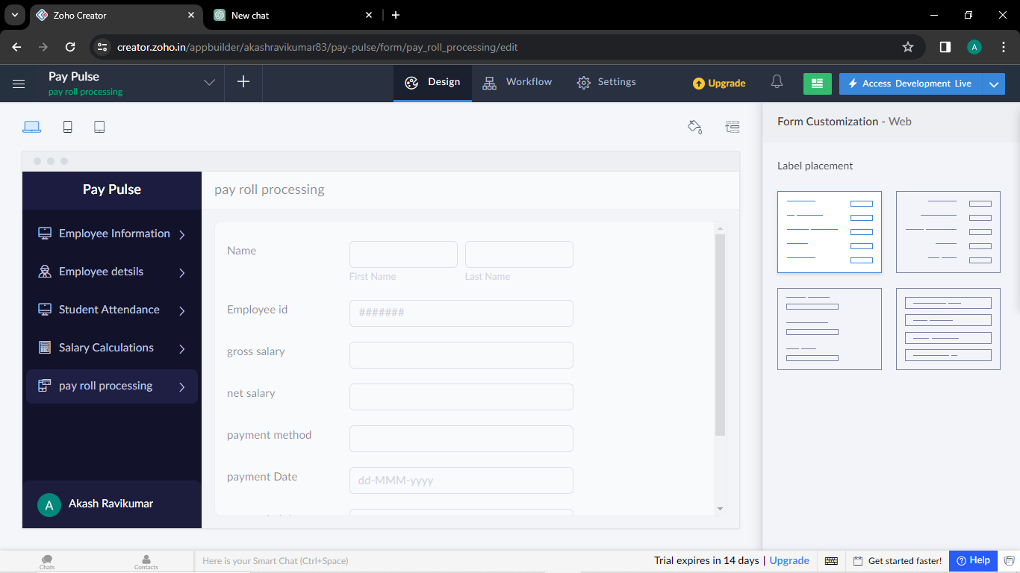

R.Akash 192121091